4.1
clc;
clear;
close all;

% Specifications
Fs = 1000; % Sampling frequency
Fc = 200; % Cut-off frequency
N = 50; % Filter order

% Normalized cut-off frequency
Wn = Fc/(Fs/2);

% FIR Low-pass filter using Rectangular window
b = fir1(N, Wn, 'low', rectwin(N+1));

% Frequency response
[H, f] = freqz(b, 1, 1024, Fs);

% Plot frequency response
figure;
plot(f, 20*log10(abs(H)));
grid on;

xlabel('Frequency (Hz)');
ylabel('Magnitude (dB)');
title('FIR Low-Pass Filter - Rectangular Window');
xlim([0 Fs/2]);

% Display coefficients
disp('Filter Coefficients:');
disp(b);

output:
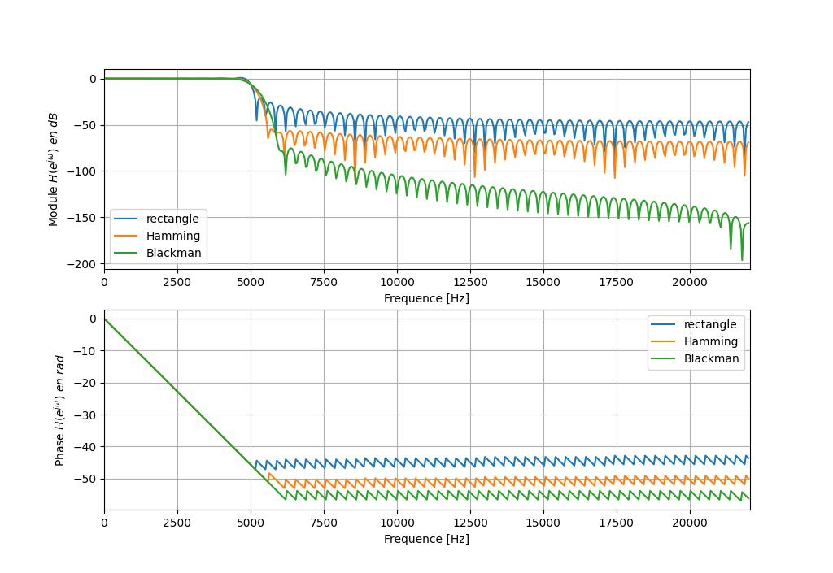
- Passband: approximately 0–200 Hz
- Cut-off frequency: 200 Hz
- Stopband begins after the transition region
- Rectangular window has relatively high side lobes.
4.2
clc;
clear;
close all;

% Specifications
Fs = 1000; % Sampling frequency
Fc = 200; % Cut-off frequency
N = 50; % Filter order

% Normalized cut-off frequency
Wn = Fc/(Fs/2);

% FIR Low-pass filter using Hamming window
b = fir1(N, Wn, 'low', hamming(N+1));

% Frequency response
[H, f] = freqz(b, 1, 1024, Fs);

% Plot frequency response
figure;
plot(f, 20*log10(abs(H)));
grid on;

xlabel('Frequency (Hz)');
ylabel('Magnitude (dB)');
title('FIR Low-Pass Filter - Hamming Window');
xlim([0 Fs/2]);

% Display coefficients
disp('Filter Coefficients:');
disp(b);

output:
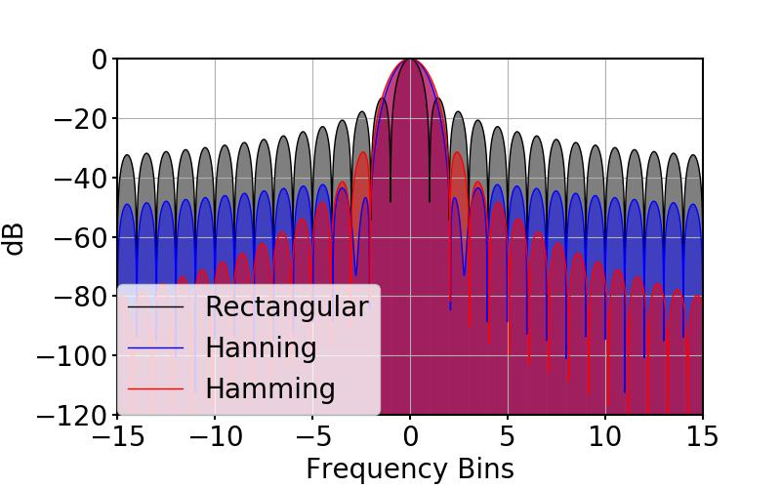
- Passband: approximately 0–200 Hz
- Hamming window produces lower side lobes than the rectangular window.
- Stopband attenuation is better than the rectangular-window design.
- The transition band is somewhat wider.

4.3
clc;
clear;
close all;

Fs = 1000;
Fc = 200;
N = 50;

Wn = Fc/(Fs/2);

% Design filters
b_rect = fir1(N, Wn, 'low', rectwin(N+1));
b_hamm = fir1(N, Wn, 'low', hamming(N+1));
b_hann = fir1(N, Wn, 'low', hann(N+1));

% Frequency responses
[H1, f] = freqz(b_rect, 1, 1024, Fs);
[H2, ~] = freqz(b_hamm, 1, 1024, Fs);
[H3, ~] = freqz(b_hann, 1, 1024, Fs);

% Plot comparison
figure;
plot(f, 20*log10(abs(H1)));
hold on;
plot(f, 20*log10(abs(H2)));
plot(f, 20*log10(abs(H3)));

grid on;
xlabel('Frequency (Hz)');
ylabel('Magnitude (dB)');
title('Comparison of FIR Low-Pass Filters');
legend('Rectangular', 'Hamming', 'Hanning');
xlim([0 500]);
ylim([-100 5]);
output:
